11. In a class of Grade 3, Mathematics Teacher asked for the Acronym PEMDAS?. All of them

are thinking for a while. A smart kid of the class Kishore of the class says it is Parentheses,

Exponentiation, Multiplication, Division, Addition, Subtraction. Can you write a C Program

to help the students to understand about the operator precedence parsing for an expression

containing more than one operator, the order of evaluation depends on the order of

operations

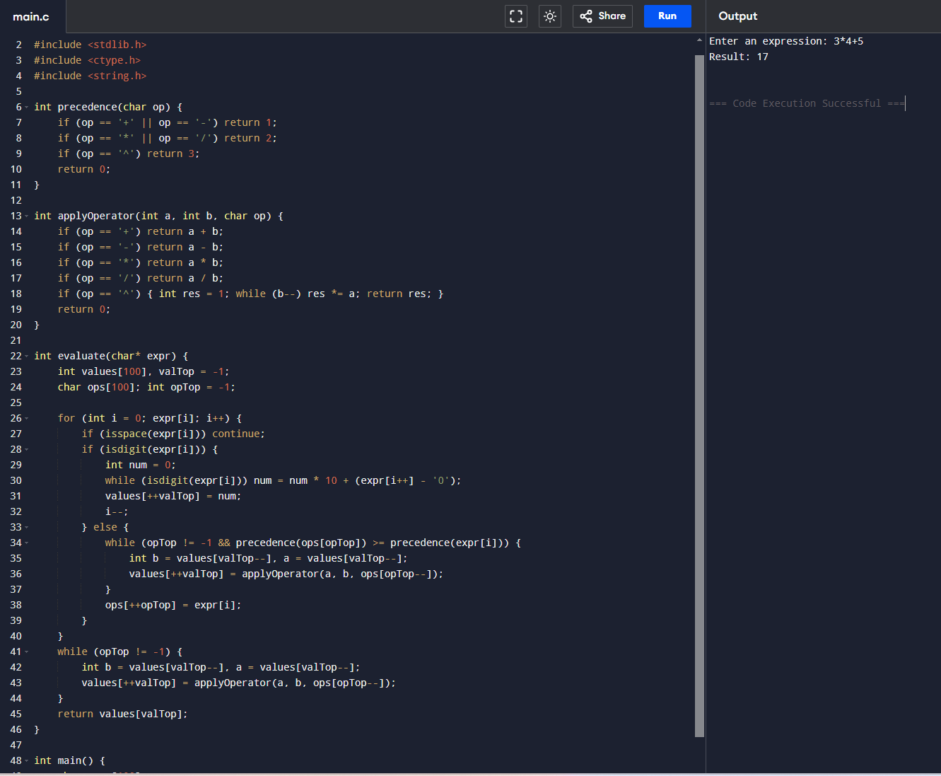

12. The main function of the Intermediate code generation is producing three address code

statements for a given input expression. The three address codes help in determining the

sequence in which operations are actioned by the compiler. The key work of Intermediate

code generators is to simplify the process of Code Generator. Write a C Program to

Generate the Three address code representation for the given input statement.

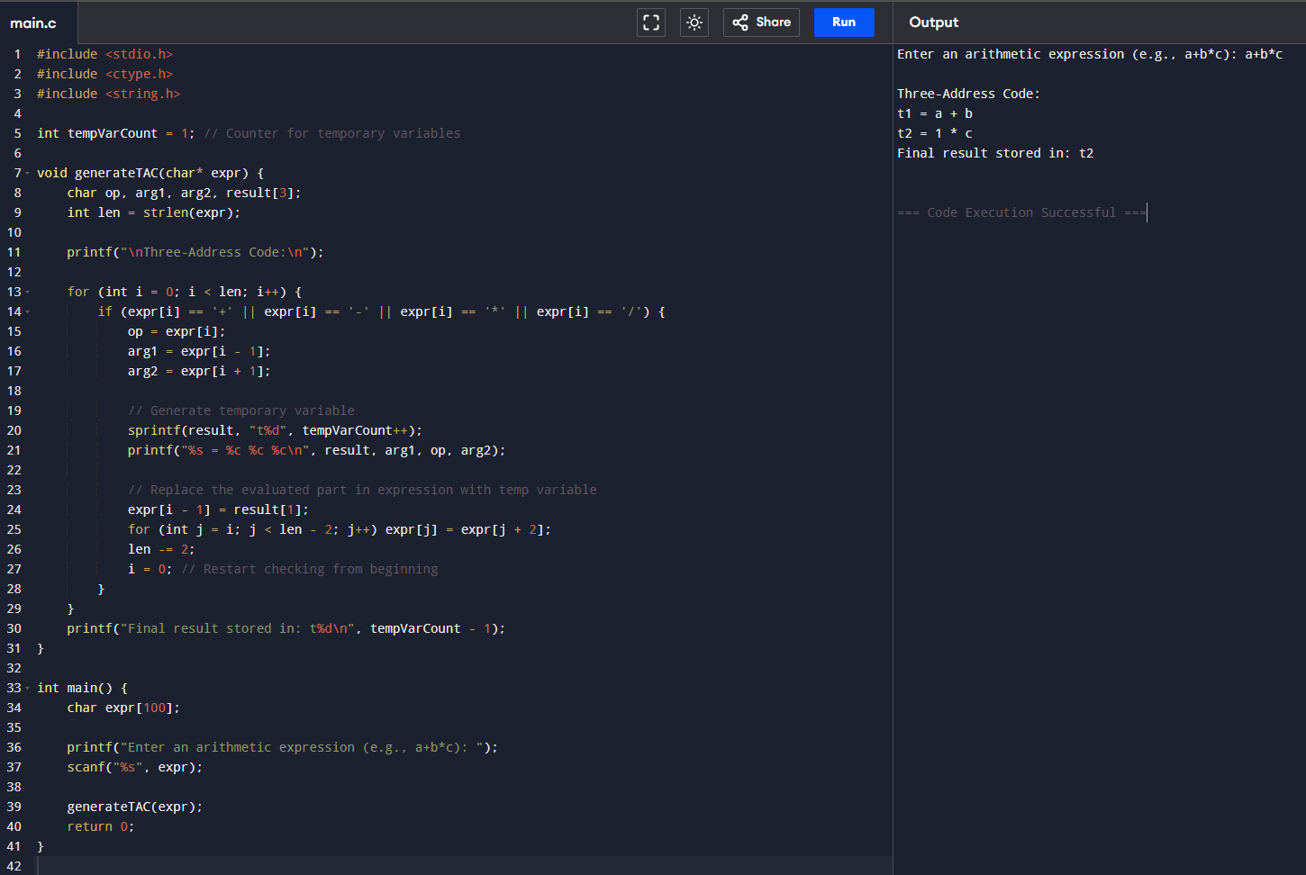

13. Write a C program for implementing a Lexical Analyzer to Count the number of characters,

words, and lines

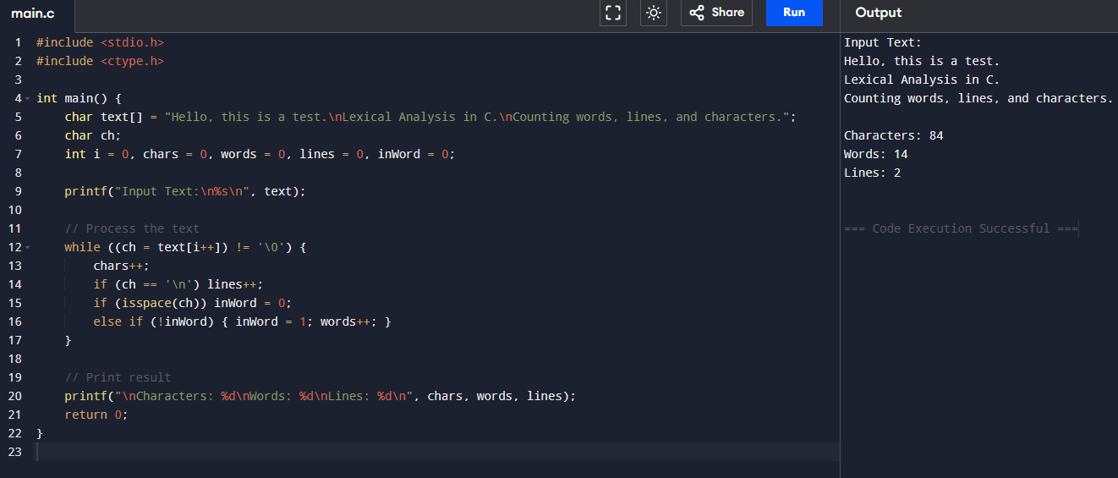

14. Write a C Program for code optimization to eliminate common subexpression.

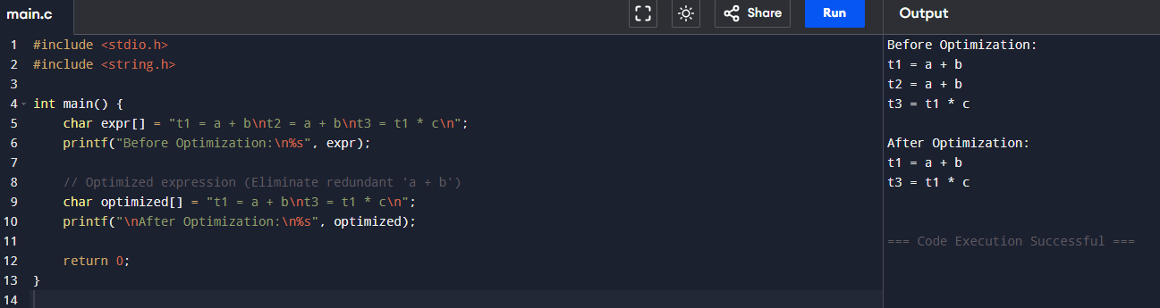

15. Write a C program to implement the back end of the compiler.

